Ideation Phase
Empathize & Discover

Date | 29 June 2026
Team ID | Individual Project
Project Name | Library Book Request Management System
Maximum Marks | 4 Marks

Empathy Map Canvas:
The Empathy Map helps understand the needs, thoughts, emotions, and challenges of the users interacting with the Library Book Request Management System. It provides insights into the user's experience and helps design a solution that improves the overall library book request process.
Example:
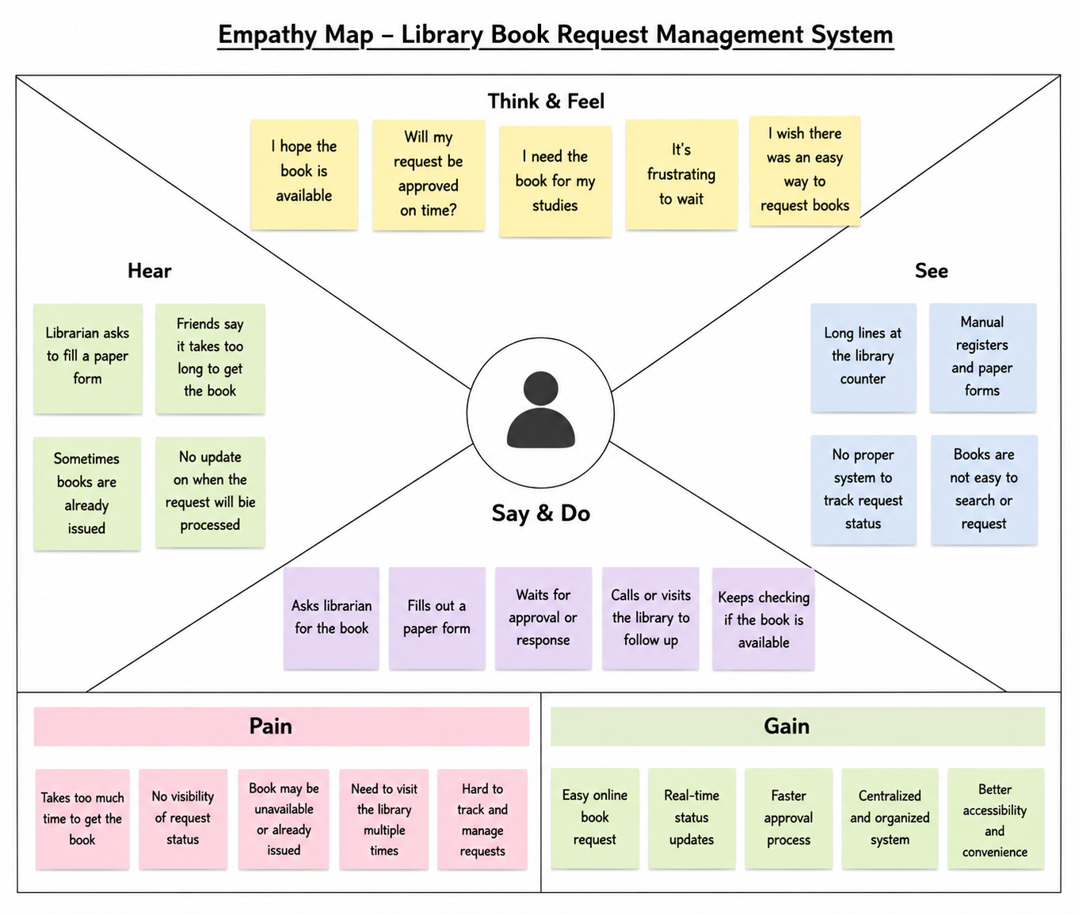

Empathy Map Details

Think & Feel
- I need the book for my studies.
- I hope the request gets approved quickly.
- I want an easy way to request books.

Hear
- Fill out the request form.
- Your request is under review.
- The requested book is available.

See
- Manual book request process.
- Long waiting time.
- Paper records.

Say & Do
- Submit a book request.
- Check request status.
- Contact the librarian for updates.
- Visit the library when approved.

Pain
- Manual paperwork.
- Delayed approval.
- Difficult to track request status.
- Multiple visits to the library.

Gain
- Online book request.
- Faster approval process.
- Real-time status tracking.
- Better user experience.

